Name:Hadeer Ur Rehman(12413)

Design and Analysis of Algorithms

**Maximum marks: 10 Instructions**

The purpose of this assignment is to give you hands on practice. It is expected that students will solve the assignment themselves. The Following rules will apply during the evaluation of assignment.

1. Cheating from any source will result in zero marks in the assignment.
2. Any student found cheating in any of the two assignments submitted will be awarded "F" grade in the course.
3. No assignment after due date will be accepted through email Assignment No. 1

Consider the Merge Sort Algorithm given below

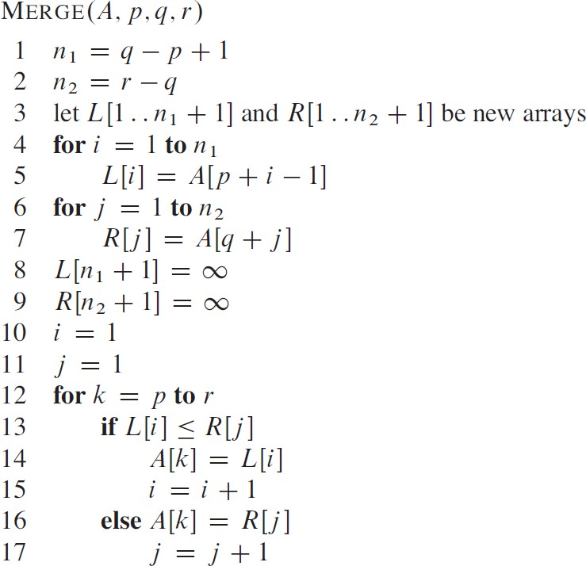

# What is the Invariant of Merge Sort?

1. Analyze Merge Sort Algorithm by finding T(n) the running time of MERGE-SORT on an input of n values.
2. What is the best-case running time?
3. What is the worst-case running time?

?